Report

I designed adder and shifter myself. All the tests I applied were successful.

The program is working properly.

1) Adder Design

1-Bit Full Adder

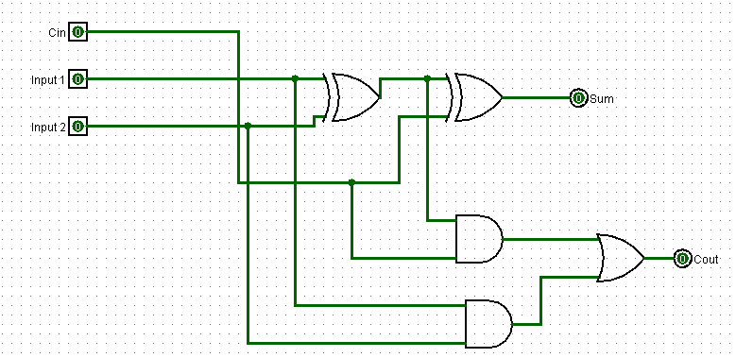

This circuit is a simple one bit full adder circuit. Sum of 2 1-bit numbers as a result. I designed 32 bit adder using 32 of these full adder.

32-Bit Adder

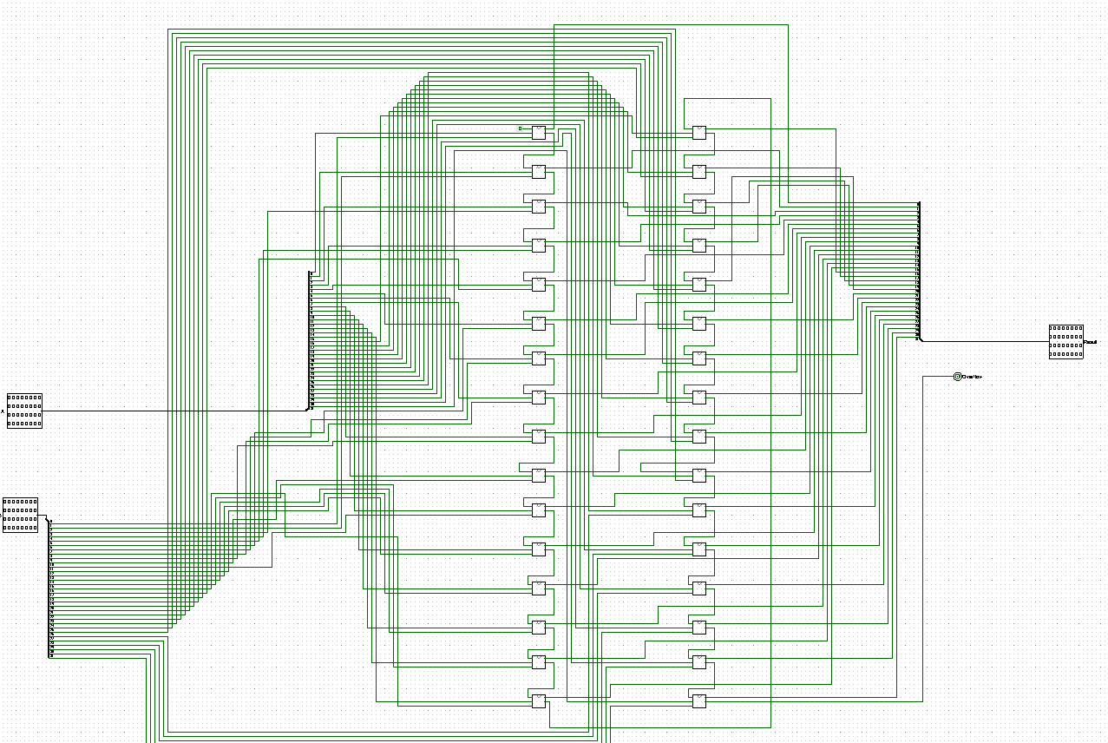

Adds all bits with 1 bit full adder in sequence and writes them to 32 bit output result.

If the Cout(carry out) of the msb bit is 1, it generates a 1 bit overflow signal for overflow.

2) 64 bit Shifter Design

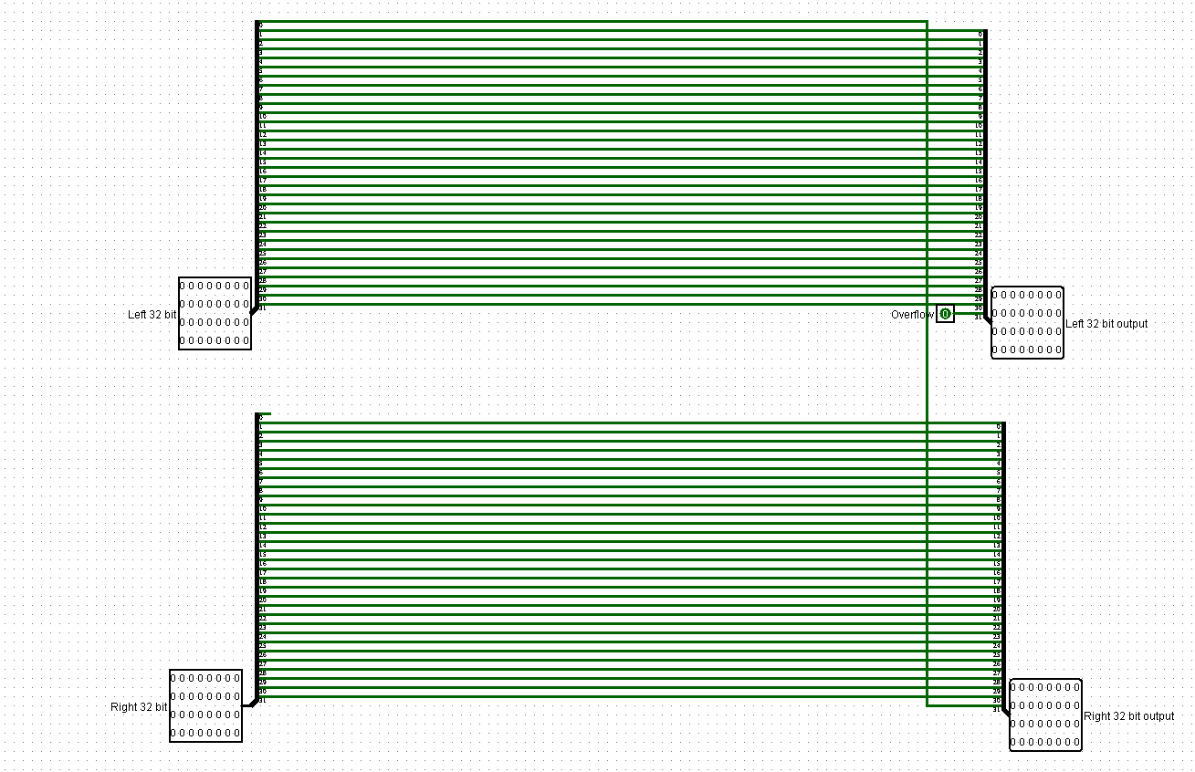

This shifter performs a 1-bit shift operation for 64 bits.

It shifts all bits 1 step to the right starting from the msb to the lsb of the 64 bit input.

3) Datapath

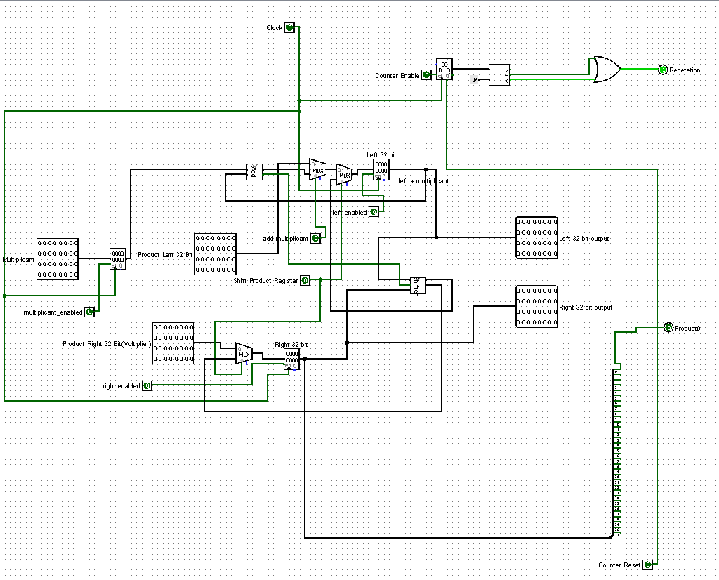

Datapath Signals:

Multiplicant_Enabled: When this signal is 1, it assigns the multiplicant input to the register.

Left Enabled,Right Enabled: Assigns left and right 32 bits of product input to registers.

Add_Multiplicant: When this signal is 1, it adds the left 32 bits of the product with multiplicand and writes it back to the left 32 bits.

Counter Enable: When this signal is 1, increments the counter by 1

Shift Product Register: When this signal is 1, the product is shifted 1 bit to the right.

Product0: Output the less significant bit of the product.

Repetation: It examines whether Counter has reached 32 or not.

4)Control Unit

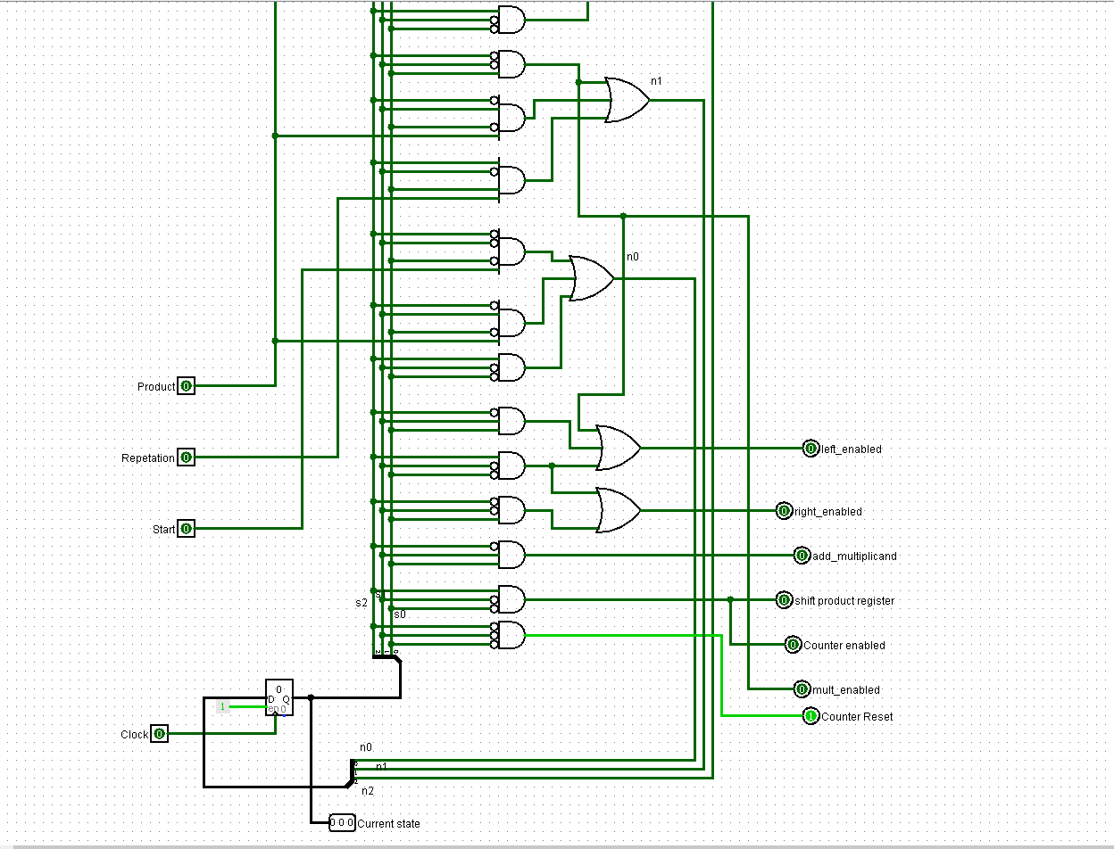

It is the circuit that generates the signals required for datapath.

It makes state transitions according to the repetation and Product signal from the datapath. Start signal is the button input entered by the user. When this button is pressed, the program starts.

5) Program Main

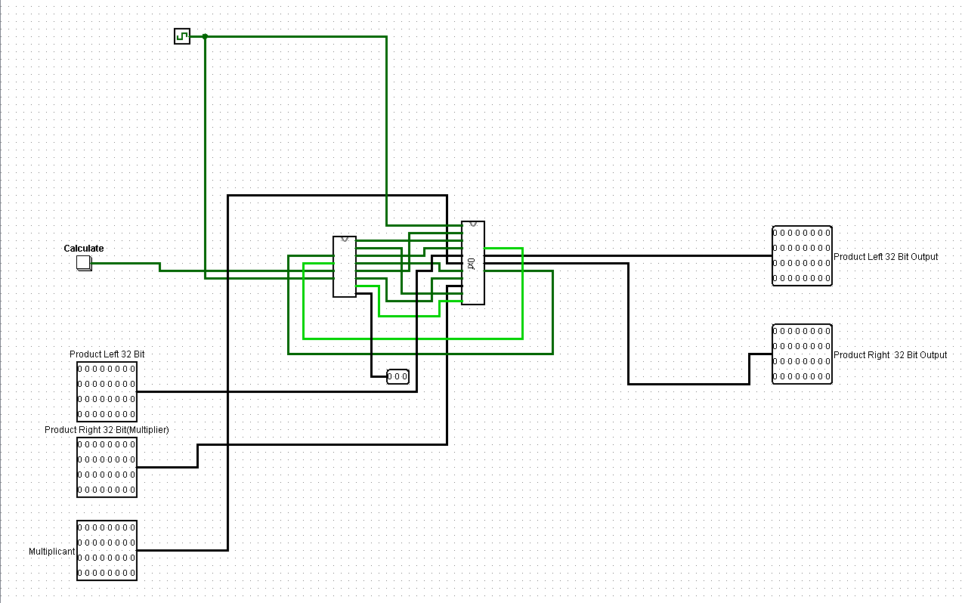

Left 32 bit input is put for representation purposes. It takes 32 bit multiplier and 32 bit multiplicant input and gives the product of these two numbers.

TESTS

1) 00….001110(14) x 00…0011(3) = 00…000101010 = 42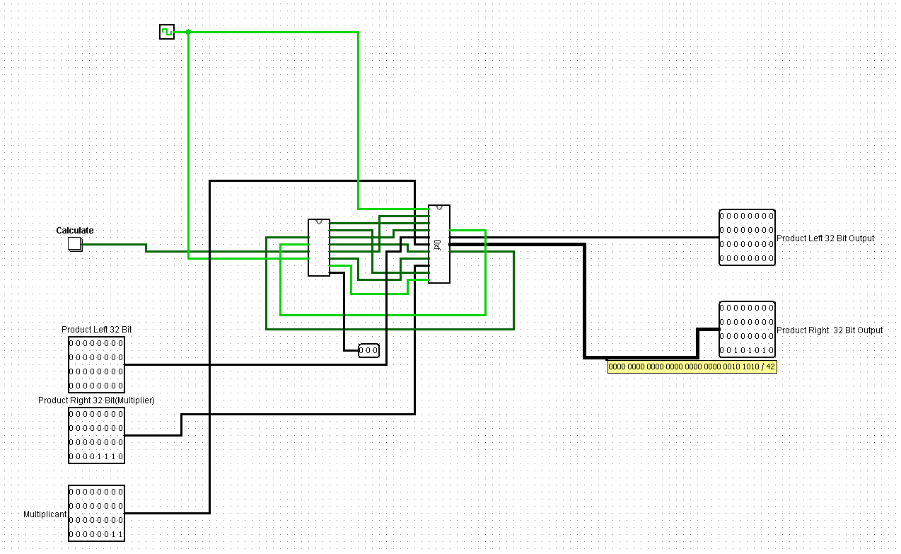

2)00...000100(4)x00..001100000000100(6148)=00…0110000000010000=24592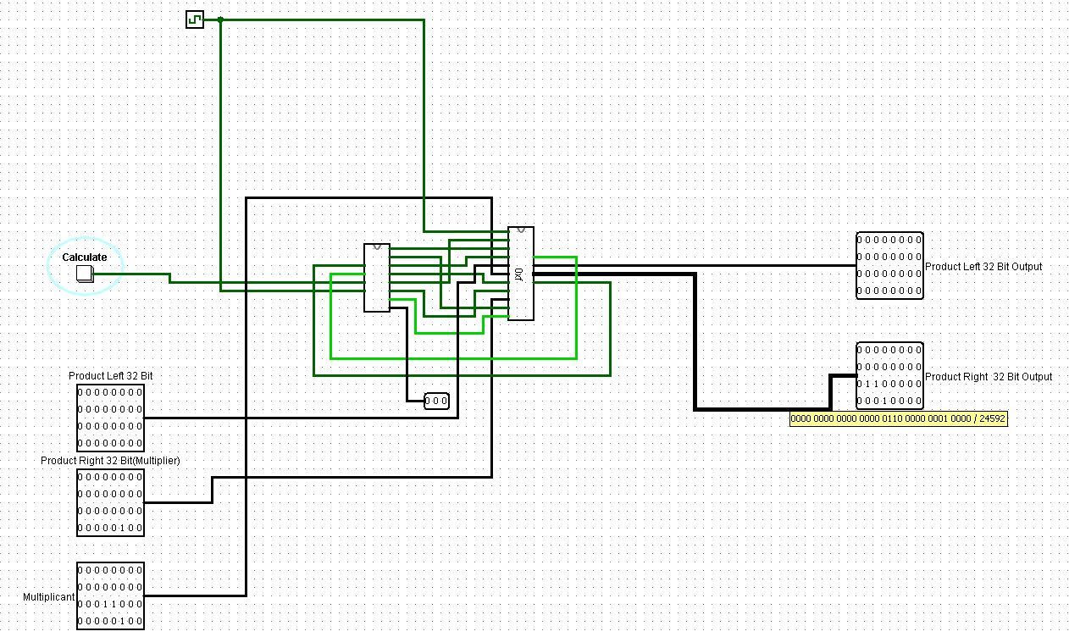

3)00…010100(20) x 00…00110(6) = 00…01111000 = 120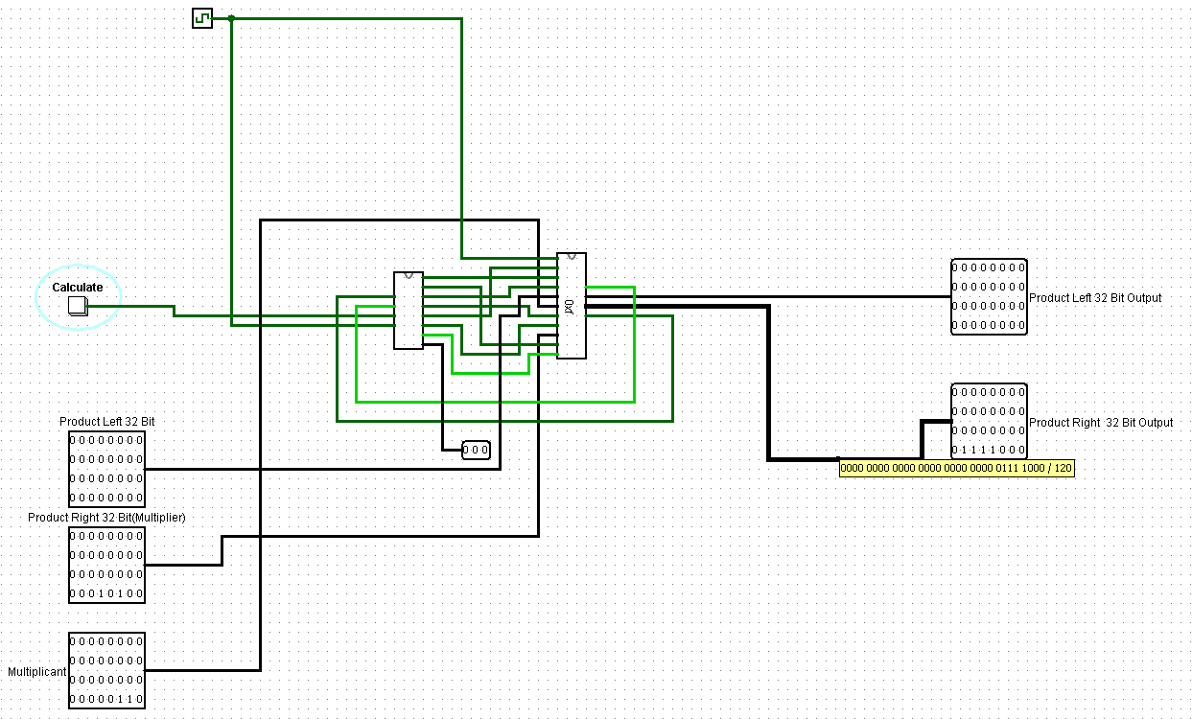

4)Trial With Big Numbers

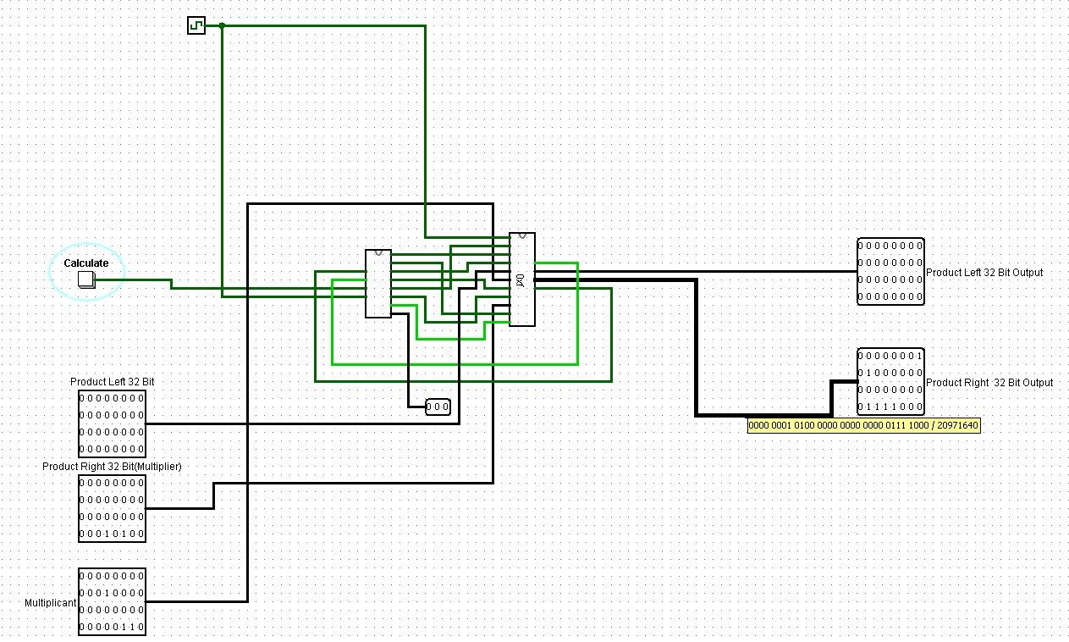

5)32 x 22 = 704

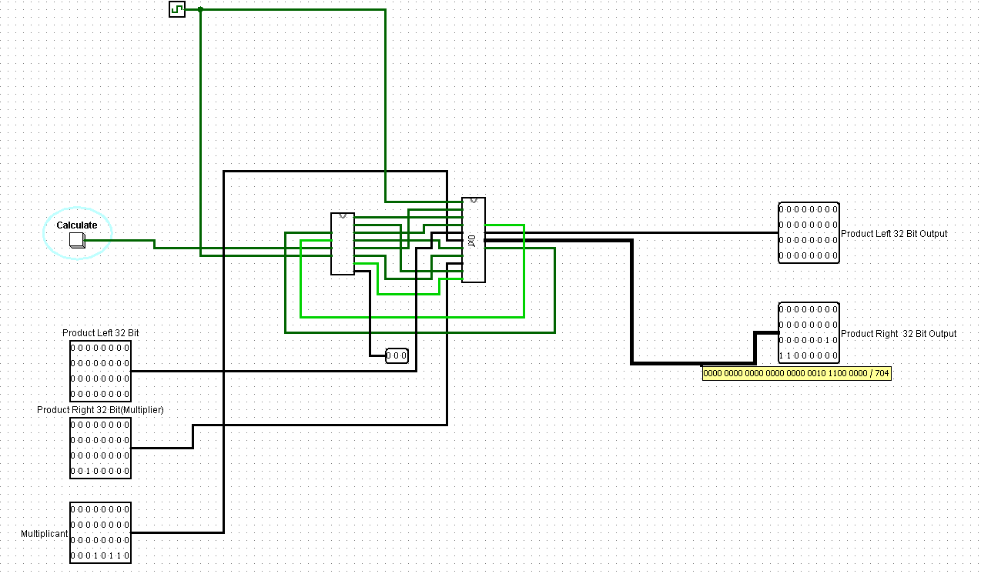

6) 15 x 2 = 30

